# CS 255 System Design Document Template

## UML Diagrams

### UML Use Case Diagram

### UML Activity Diagrams

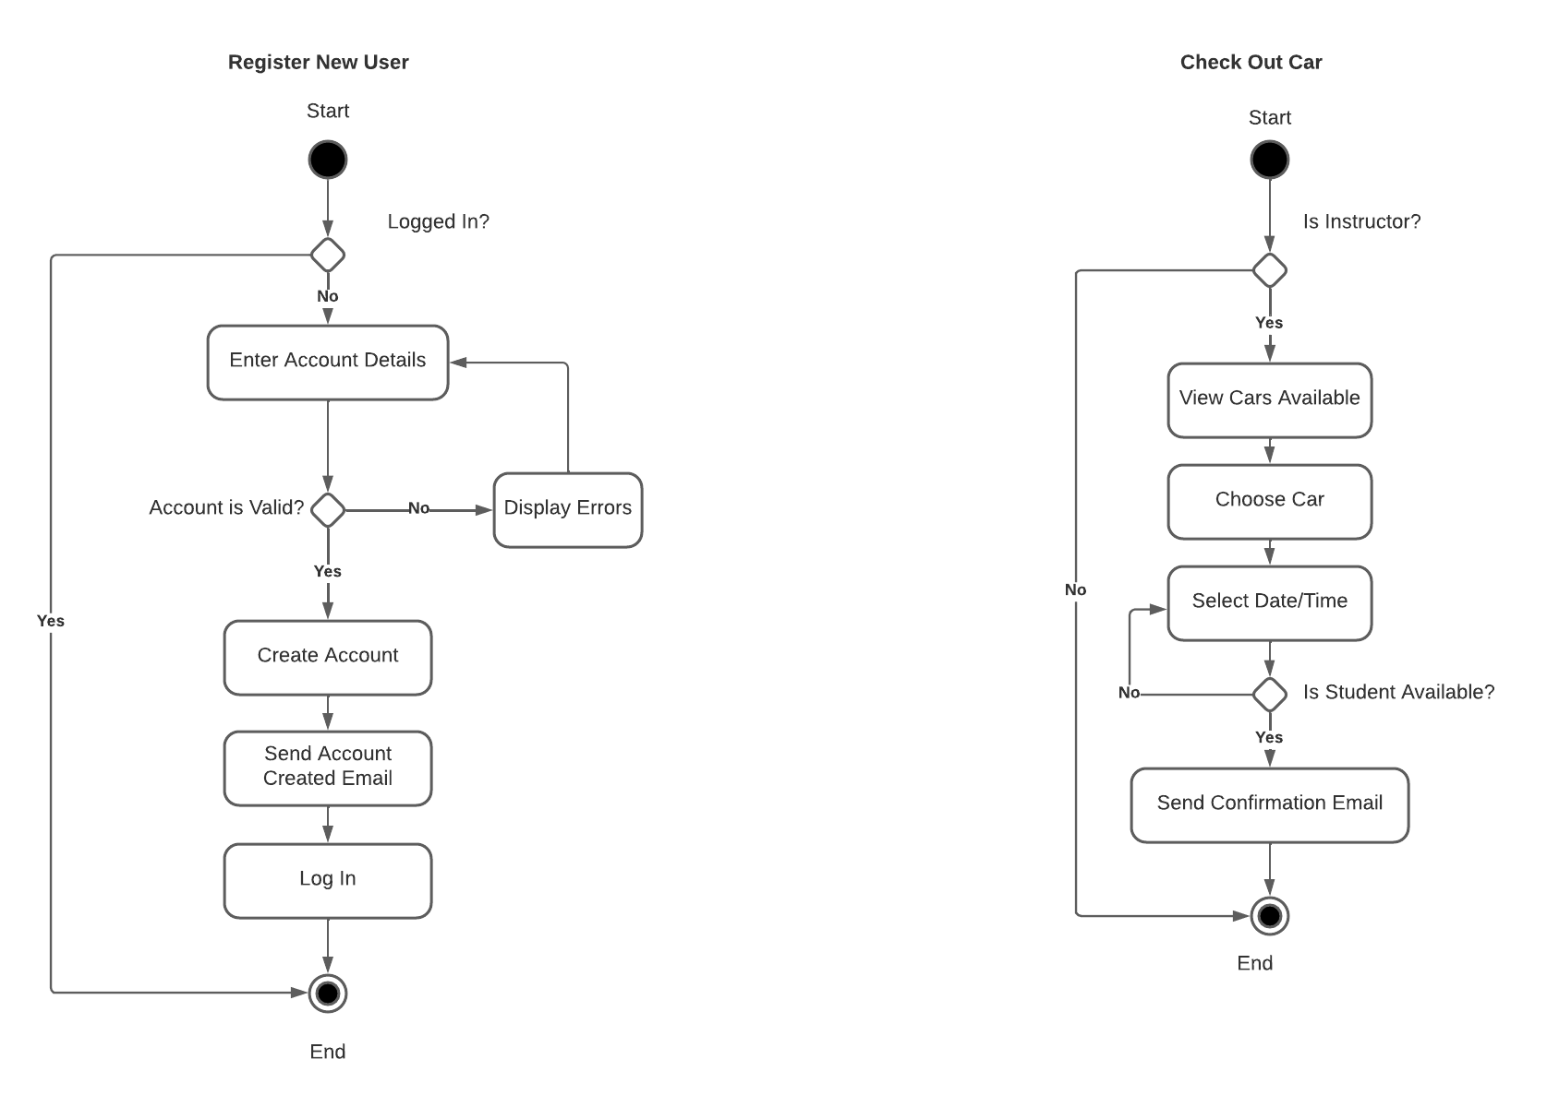

### UML Sequence Diagram

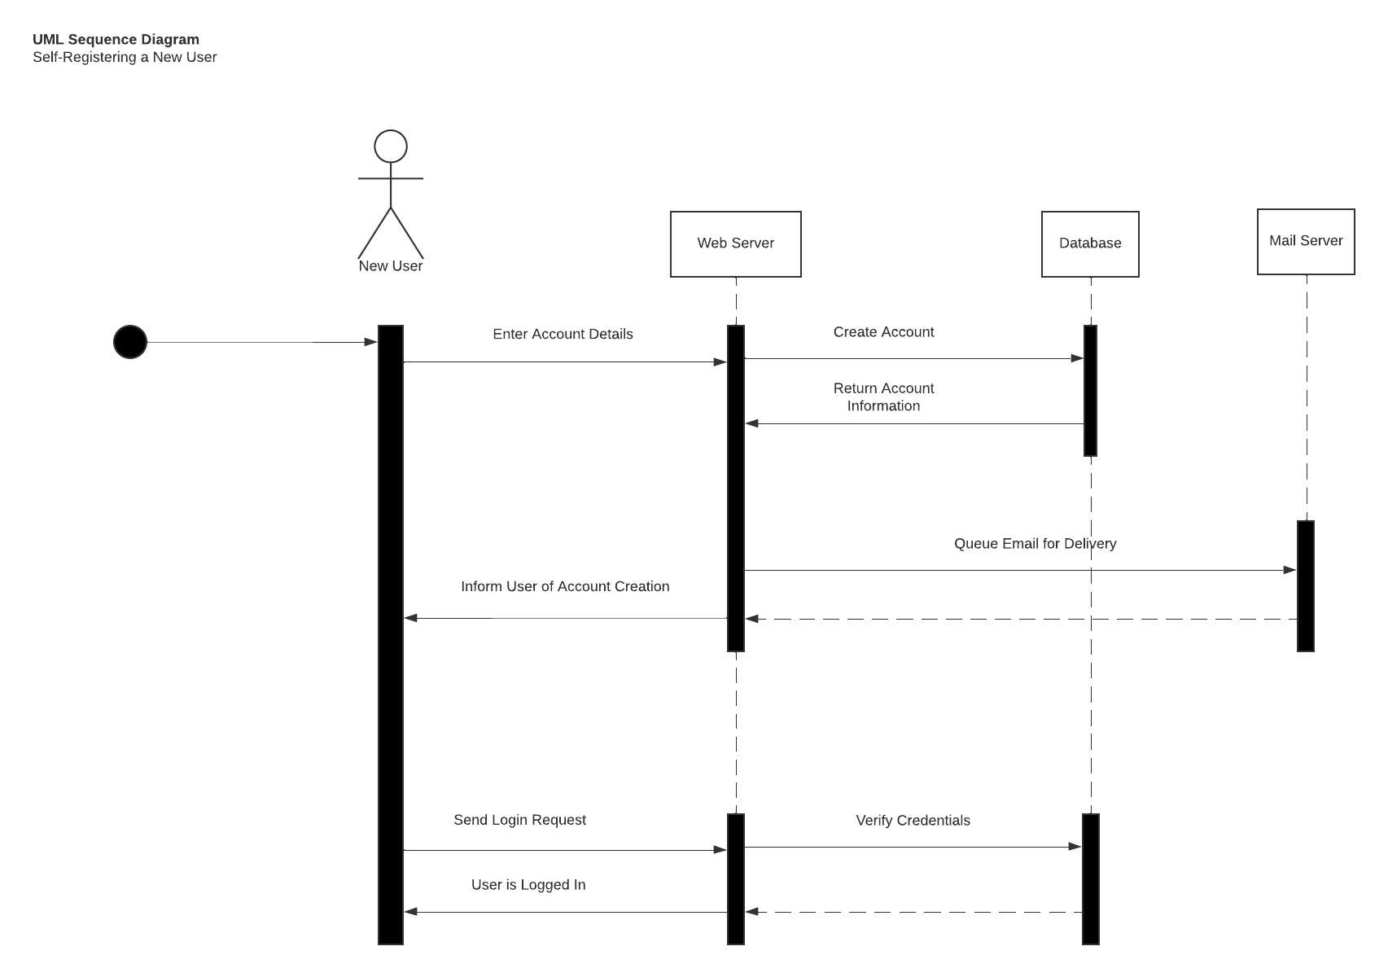

### UML Class Diagram

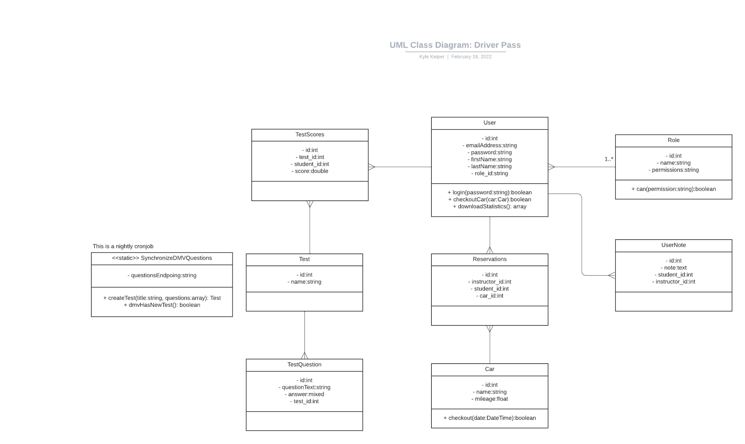

## Technical Requirements

Based on the diagrams above, there are a few technical requirements; namely:

1. Must run on Linux (requires Cron)
2. Needs HTTP Server Software and Database Server (persists information)
3. Needs Scripting Language to Script the HTTP server’s behavior (PHP / Python / Ruby, etc)
4. Needs Outside Internet Connectivity (fetches questions from DMV)
5. Needs >= 4Gb of RAM / 60 Gb Storage Space
6. User needs a Browser
7. Developer needs IDE

I’m not sure what else to say for the technical requirements. VCS would probably be a good recommendation as well, probably Git.